Project #1

Railway Reservation System

CSE 3330

By:

Muhammad Muawiz Farooqi

Faith Gutierrez

Tahera Fatima

**Tools used for the Project (Readme File)**

* Lucid Chart to create the ER Diagram
* MySQL to create the Create Statements
* Sqlite3 to write and execute the queries (screenshots shown below)

**ER Diagram**

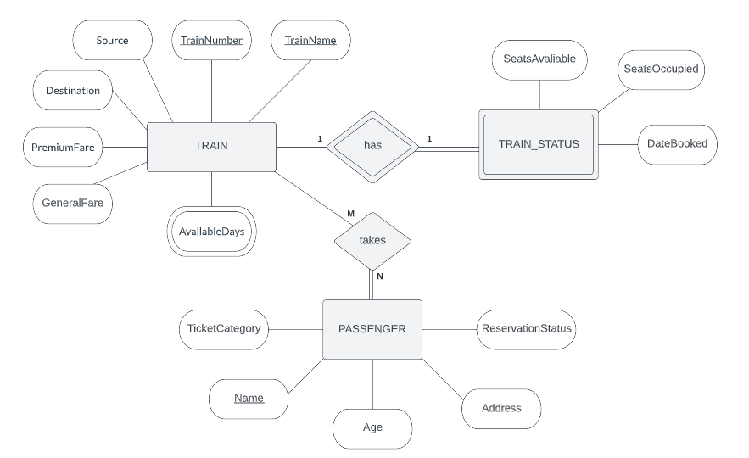

**SQL Create Statements**

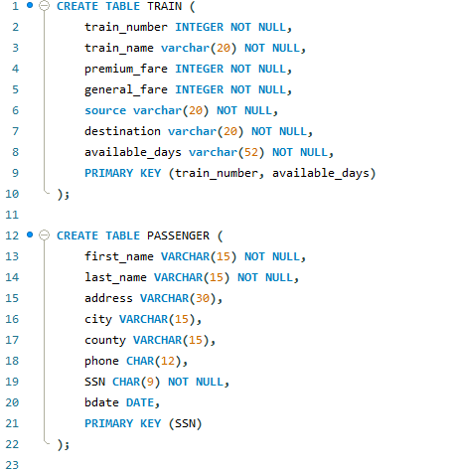

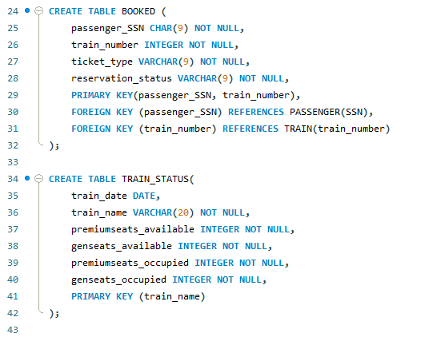

**Method to Load Data into Tables**

We used .import to load the data into TRAIN_STATUS, PASSENGER, and BOOKED. Then we used INSERT statements to load the data into TRAIN. Lastly, we deleted the first row from TRAIN_STATUS, PASSENGER, and BOOKED to remove the column labels that were imported from the .csv files.

**SQL Queries**

**2. Input a passenger’s last name and first name and retrieve all trains they are booked on.**

* **Example: First name = Art, Last name = Venere**

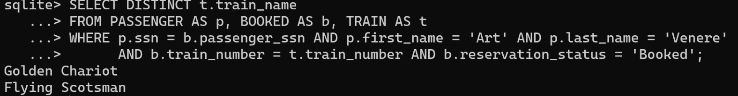

**3. Input the Day and list the passengers travelling on that day with confirmed tickets.**

* **Example: Day = Saturday**

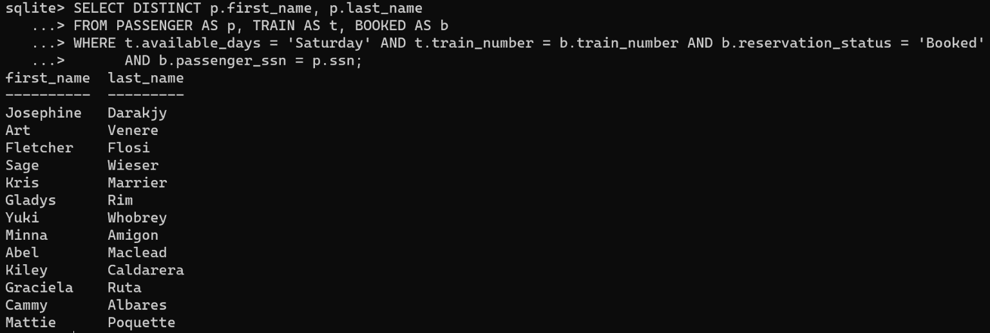

**4. User input the age of the passenger (50 to 60) and display the train information (Train Number, Train Name, Source and Destination) and passenger information (Name, Address, Category, ticket status) of passengers who are between the ages of 50 to 60.**

* **Example: All passengers between the ages of 50 and 60 (inclusive)**

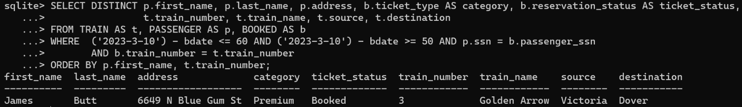

**5. List train name, day, and number of passengers on that train**

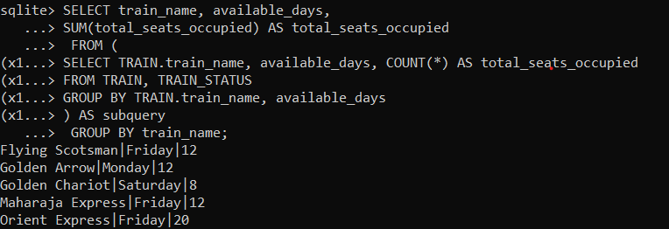

**6. Enter** **a train name and retrieve all the passengers with confirmed status traveling** **in that train.**

* **Example: TRAIN.train_name= Flying Scotsman**

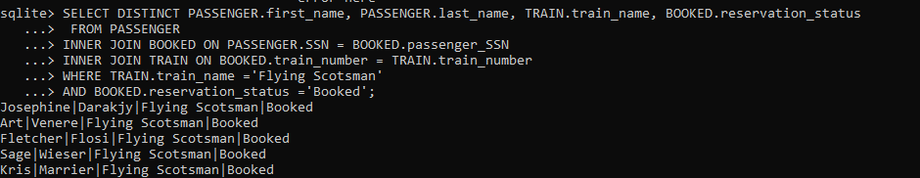

**7. List passengers that are waitlisted including the name of the train.**

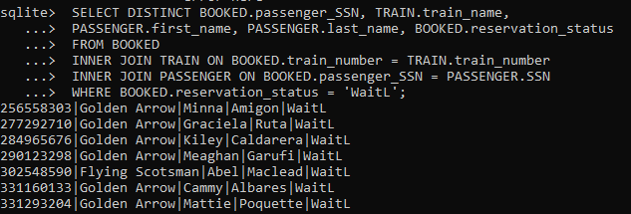

**8. List passengers that have '605' phone area code in descending order.**

**9. List name of passengers that are traveling on Thursdays in ascending order.**

**Contribution List**

**Muhammad Muawiz Farooqi:**

* ER diagram: TRAIN entity, attributes, and relationships.
* Queries: 2-4
* Create Statements: TRAIN
* .csv files: modified date format in PASSENGER, added multivalued attributes in TRAIN.

**Faith Gutierrez:**

* ER diagram: PASSENGER and TRAIN_STATUS entity and attributes.
* Queries: 8 and 9.
* Create Statements: PASSENGER and BOOKED
* Explain method used to load data into tables.

**Tahera Fatima:**

* Queries: 5-7
* Create Statements: TRAIN_STATUS
* Tools used for the Project.

**HONOR CODE**

**I pledge, on my honor, to uphold UT Arlington's tradition of academic integrity, a tradition that values hard work and honest effort in the pursuit of academic excellence.**

**I promise that I will submit only work that I personally create or that I contribute to group collaborations, and I will appropriately reference any work from other sources. I will follow the highest standards of integrity and uphold the spirit of the Honor Code.**

**________Muhammad Muawiz Farooqi______**

**________Faith Gutierrez__________________**

**________Tahera Fatima___________________**